MIDDLE EAST TECHNICAL UNIVERSITY
Department of Electrical and Electronics
Engineering

EE 583 ARTIFICIAL INTELLIGENCE
Spring 2006

PROJECT INTERMEDIATE REPORT

Project Topic

Simultaneous Localization and Mapping Implementation on Khepera Robot Simulator

Project Group

Bengi Koç , Barış Tanrıverdi , Salim Sırtkaya

TABLE OF CONTENTS

1. Problem Definition 3
2. Summary of Previous Efforts 4
3. FRAMEWORK 6
1.1. Basics of fastSLAM Approach [7] 6
1.1.1. Bayesian Approach to SLAM: 6
1.1.2. FastSLAM Details 7
1.1.3. Computational Complexity of fastSLAM 8
1.1.4. Comparison of fastSLAM with EKF 8
1.2. Outline of the fastSLAM Approach 9
1.3. Outcome of the Implementation 10
4. Work Allocation for Team Members 10
5. References 10

LIST OF FIGURES

Figure 1 A vehicle taking relative measurements to environmental landmark for SLAM 3
Figure 2 Performance of different SLAM algorithms 6
Figure 3 A Bayesian network depicting the structure of the SLAM problem 7

LIST OF TABLES

Table 1 Task environment specifications 4

Problem Definition
A critical ability of autonomous robots is navigation. The functions of navigation can be expressed in four questions: where am I going, which is the best way to get there, where have I been, and where am I? In order to solve these questions, the robot needs to know its environment. As the robot explores new environments, it may be part of its mission to map them. The acquisition of unknown environments is known as robotic mapping. [1]

In particular, Simultaneous Localization and Mapping (SLAM) can be described as the ability of a robot to build a map of its environment while localizing itself in that map to reach true autonomy. [2] SLAM problem tries to answer the following question: “Is it possible for an autonomous vehicle starting at an unknown location in an unknown environment to incrementally build a map of the environment while simultaneously using this map to compute the vehicle’s location?”[3]. This scenario is shown in Figure 1. [4]

Figure 1 A vehicle taking relative measurements to environmental landmark for SLAM
In this project, we’ll implement SLAM on Khepera simulator. Khepera is a circular shaped robot that has two wheels and 8 proximity sensors. The simulator is a Matlab application that simulates a Khepera robot connected to the computer in a very realistic way. The simulated Khepera is controlled from Matlab in the same way as real, physical Kheperas. We can control the wheels and take measurements from each range sensor. The simulated robot will be placed on an unknown grid map. Each grid will be represented by white or black color indicating the state of the grid, empty or full. The simulator robot will start from an initial pose and will gradually build the map of its environment while localizing itself on that map.

The problem defined in the previous paragraph can be analyzed and categorized using the tools mentioned in the class. Respective categorizations and task environment specifications are as follows:

- Problem is deterministic, sequential/episodic, partially observable, static, discrete and single agent

Table 1 Task environment specifications
Agent Type | Performance Measure | Environment | Actuators | Sensors
Khepera Robot Simulator | Speed, Consistency of the map | Grid Map of Khepera Simulator | 2 Motors Controlling 2 Wheels | 6 Proximity Sensors

Summary of Previous Efforts
The general SLAM problem has been the subject of substantial research since the inception of a robotics research community and indeed before this in areas such as manned vehicle navigation systems and geophysical surveying. A number of approaches have been proposed to address both the SLAM problem and also more simplified navigation problems where additional map or vehicle location information is made available.

The most popular of these is a feature based approach, estimation-theoretic or Kalman filter approach. The popularity of this approach is due to two main factors. First, it directly provides both a recursive solution to the navigation problem and a means of computing consistent estimates for the uncertainty in vehicle and map landmark locations on the basis of statistical models for vehicle motion and relative landmark observations. However, common to all feature based approaches, the increase in computational complexity with the size of the environment and number of landmarks is a serious drawback of this method. A number of techniques have been proposed to alleviate this problem, such as the Extended Kalman Filter (EKF), information filter and fastSLAM.

The EKF uses linearized kinematics and observation equations to generate state predictions. EKF immediately reduces the error in both the robot and the landmarks upon seeing and correctly matching a previous landmark. The covariance actually reduces the error in all landmarks simultaneously. However, EKF-based SLAM is slow to update and is not scalable in its simple form.

In information filter method the inverse of the covariance matrix is utilized instead of the covariance matrix itself. The algorithm exploits the fact that the information matrix is approximately sparse, requiring less (O(kn)) storage space. The information matrix representation allows integration of a new measurement in O(k²) computation time, but to produce a map estimate, a system of n linear equations must be solved. The equation solving is performed iteratively by relaxation. The drawback of this algorithm is its linear assumption. [5]

Fast-SLAM makes use of the observation that the landmark estimates are conditionally independent given the robot pose. Basically, the algorithm is a particle filter , in which every particle represents a sampled robot trajectory plus a set of Kalman filters estimating the position for each landmark as a Gaussian distribution. These distributions are independent, so small covariance matrices are needed, instead of one large matrix. The computation time for integrating a measurement is for particles with storage space. This algorithm can cope with uncertain landmark identification, which is a unique advantage over the other algorithms. [5] There exist other methods such as thin junction tree filter, treemap algorithm, hierarchical SLAM, relaxation based SLAM, compressed EKF etc. The performance measure of some algorithms are given in Figure 2. This figure is taken from [5].

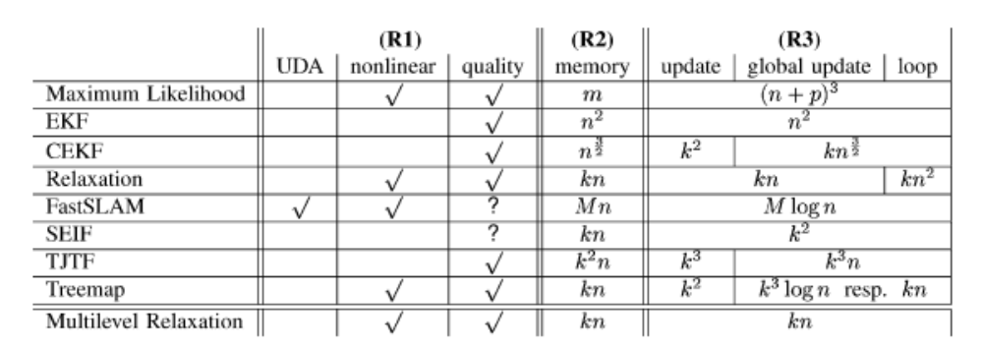
Figure 2 Performance of different SLAM algorithms

N stands for landmarks or frames, respectively, m measurements, p robot poses, and k landmarks/frames local to the robot.

UDA stands for “uncertain data association,” meaning that the algorithm can handle landmarks with uncertain identity.

FRAMEWORK
We’ll implement fastSLAM algorithm in Matlab using Kiks (a khepera simulator written in Matlab). The fastSLAM approach is discussed in the following sections.

Basics of fastSLAM Approach [6]

Bayesian Approach to SLAM:
Consider the case of a mobile robot moving through an unknown environment. The environment consists of a set of stationary landmarks. The position of landmark k with respect to some global reference frame is denoted θ_{k}. The robot moves according to a known probabilistic motion model p(s_{t}|u_{t},s_{t-1}), where s_{t} and u_{t} denote the robot configuration and the control input at time t, respectively. As the robot moves around, it takes measurements of the landmarks in its environment. A measurement z_{t}, is related to the position of a landmark through a stochastic observation model p(z_{t}|s_{t},θ,n_{t}), where θ is the set of all landmark positions and n_{t}, is the index of the particular landmark observed at time t.
The SLAM problem is that of simultaneously inferring the location of all landmarks in the environment and the path followed by the robot based on a set of measurements and inputs. Ideally, one would like to recover the posterior distribution p(s^{t}, θ₁, …, θ_{K}|z^{t},u^{t}), where K is the number of landmarks observed so far and the notation s^{t} denotes s₁,….,s_{t} (and similarly for other variables). Montemerlo provided a solution in the easier case where the data associations n₁,…n_{t} are known; that is, their solution infers p(s^{t}, θ₁, …, θ_{K}|z^{t},u^{t},n^{t}).

FastSLAM Details
The key observation underlying the FastSLAM approach is that given a known robot path, measurements corresponding to different landmarks are independent of each other. This is illustrated in Figure 3 where the SLAM problem is represented as a Bayesian network. Observe that measurements corresponding to the landmark locations θ₁ and θ₂ are only linked together through their joint dependence on the robot path s^{t}. Using this observation to factor the desired posterior distribution yields
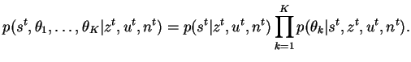

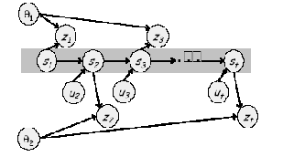

Figure 3 A Bayesian network depicting the structure of the SLAM problem
This factorization decouples the SLAM problem into a path estimation problem and individual conditional landmark location problems. In FastSLAM, a particle filter is used to estimate the path of the robot by maintaining an estimate of its current configuration. Each particle maintains its own estimate of the landmark locations. Because these are conditionally independent of each other given robot path, they may each be maintained by a low-dimensional EKF.
Based on the control input u_{t}, a measurement z_{t} and its data association n_{t}, a FastSLAM update is performed as follows. First, each particle is updated individually. For a particle m, this involves updating the local pose estimate s_{t}^{[m]} by sampling the motion model. The measurement z_{t} and data association n_{t} are then used to update the appropriate local landmark location estimate θ_{nt}^{[m]} using the standard EKF equations. Each particle is assigned an importance weight proportional to the likelihood of the measurement given the estimated robot pose. This quantity is computed in the prediction stage of the EKF. Once all particles have been updated, a new set of particles is generated through importance sampling, which involves drawing samples from the old particle set with a probability proportional to their importance weights.

Computational Complexity of fastSLAM
Assuming the number M of particles remains fixed over time and there are K landmarks, a naive implementation of this algorithm results in O(MK) time complexity for a SLAM update, mainly because of the importance resampling stage which requires the landmark estimates of a given particle to be copied an arbitrary number of times. The authors show, however, that this complexity may be further reduced to O(M logK). This is achieved by storing the Gaussian landmark location estimates for each particle in tree-like data structures. This transforms the linear time copying operation into a logarithmic time operation which involves modifying a path in the tree.

Comparison of fastSLAM with EKF
FastSLAM offers many improvements over the traditional EKF-based SLAM framework. In addition to the obvious reduction in computational complexity, the technique intrinsically provides a way of maintaining several data association hypotheses. This is an important advantage, given that a single data association error can cause the EKF-based strategy to fatally diverge. In FastSLAM particles with incorrect data association eventually ``die'' because of their low importance weights, thereby reducing the impact of such errors. Computational efficiency and robustness, however, come at a cost. Indeed, maintaining one map of the environment within each particle leads to the important question of how these maps, should be merged after sufficient exploration. This question becomes especially complicated in the case of unknown data association, where all particles do not necessarily maintain the same number of landmarks. Curiously, the issue is barely mentioned in the original papers.

Outline of the fastSLAM Approach
Loop over all particles
Sample new pose
Calculate measurement likelihoods
measurement prediction
calculate Jacobian
measurement covariance
likelihood of correspondence
importance factor of new landmark
max likelihood correspondence
new number of features in map
update Kalman filters
// is new feature?
Yes
// initialize mean
// initialize covariance
// initialize counter
NO
// is observed feature?
yes
/ calculate Kalman gain
// update mean
// update covariance
// increment counter

no// all other features
// copy old mean
// copy old covariance
// should feature have been observed?
No
// do not change
Yes,
//decrement counter
// discard dubious features

// construct new particle set
// resample M particles

end algorithm

Outcome of the Implementation

The fastSLAM algorithm will run on Kiks, khepera simulator. The initial map, which is not known by the simulated robot, will be loaded and the algorithm will start from an initial pose. The simulated robot will have an explorer nature and try to navigate through the whole map until it finishes SLAM calculation. The output of the algorithm will be a map estimation.
Therefore the outcome will be a software package with a graphical user interface that accomplishes the above told SLAM task.

Work Allocation for Team Members
Bengi Koç
Details of Khepera simulator, fastSLAM algorithm design, integration with Kiks, Kiks coding

Barış Tanrıverdi
fastSLAM detailed research, fastSLAM algorithm design, fastSLAM algorithm implementation (coding), robot motion planning

Salim SIRTKAYA
Previous work about SLAM, fastSLAM algorithm design, implementation of Kalman filter (coding), integration with Kiks

References
[1] Biologically-inspired robotic mapping as an alternative to metric and topological approaches , Alejandra Barrera Ramirez, Alfredo Weitzenfeld Ridel
[2] Local Maps Fusion for Real Time Multirobot Indoor Simultaneous Localization and Mapping* , Diego Rodriguez-Losada, Fernando Matia and Agustin Jimenez
[3] ARIA and Matlab IntegrationWith Applications , Jonas Borgström
[4] Simultaneous Localization and Mapping, 2002 Summer School, Eduardo Nebot Australian Centre for Field Robotics The University of Sydney NSW 2006 Australia
[5] A Multilevel Relaxation Algorithm for Simultaneous Localization and Mapping , Udo Frese, Per Larsson, and Tom Duckett
[6] http://

